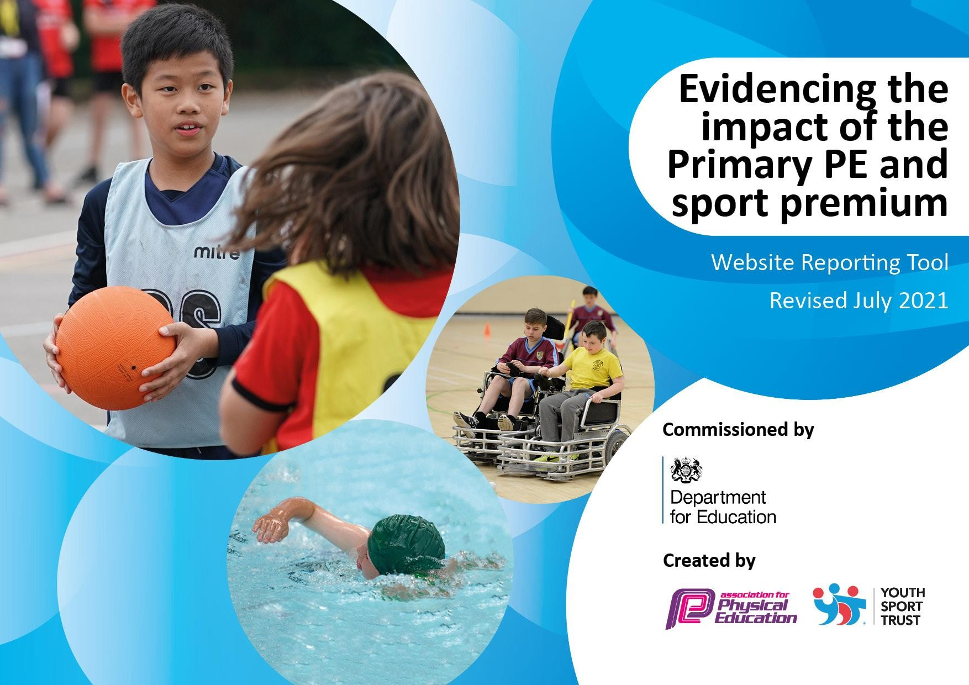

Details with regard to funding
Please complete the table below.

Total amount carried over from 2021/22 | £ 3,693
How much (if any) do you intend to carry over from this total fund into 2023/24? | £ 0
Total amount allocated for 2022/23 | £ 17,800
Total amount of funding for 2022/23. To be spent and reported on by 31st July 2023. | £ 21,693
Swimming Data
Please report on your Swimming Data below.

Meeting national curriculum requirements for swimming and water safety.  N.B. Complete this section to your best ability. For example you might have practised safe self-rescue techniques on dry land which you can then transfer to the pool when school swimming restarts.  Due to exceptional circumstances priority should be given to ensuring that pupils can perform safe self rescue even if they do  not fully meet the first two requirements of the NC programme of study | 77%
What percentage of your current Year 6 cohort swim competently, confidently and proficiently over a distance of at least 25 metres?  N.B. Even though your pupils may swim in another year please report on their attainment on leaving primary school at the end of the summer term 2022.  Please see note above | 77%
What percentage of your current Year 6 cohort use a range of strokes effectively [for example, front crawl, backstrokeand breaststroke]?  Please see note above | 77%
What percentage of your current Year 6 cohort perform safe self-rescue in different water-based situations? | 77%
Schools can choose to use the Primary PE and sport premium to provide additional provision for swimming but this must be for activity over and above the national curriculum requirements. Have you used it in this way? | No


Created by: Supported by:

Action Plan and Budget Tracking
Capture your intended annual spend against the 5 key indicators. Clarify the success criteria and evidence of impact that you intend to measure to evaluate for pupils today and for the future.

Academic Year: 2023/24 | Total fund allocated: £17,800 | Date Updated: July 2023
Key indicator 1: The engagement of all pupils in regular physical activity – Chief Medical Officers guidelines recommend that primary school pupils undertake at least 30 minutes of physical activity a day in school |  |  |  | Percentage of total allocation:
 |  |  |  | 18%
Intent | Implementation |  | Impact
Your school focus should be clear what you want the pupils to know and be able to do and about what they need to learn and to consolidate through practice: | Make sure your actions to achieve  are linked to your intentions: | Funding allocated: | Evidence of impact: what do pupils now know and what can they now do?  What has changed? | Sustainability and suggested  next steps:
To continue to Increase the amount of active  play and fitness at break times and lunch times. | Teach and support all children to gain new skills so that they can participate in games. | £740 | More children able to skip and engaging in this activity throughout playtimes in Autumn 2022. | Continue to subscribe into Sports ambassadors program.
Pupil sports ambassadors to continue to lead activities at break times and lunch times. | Train sports ambassadors and provide opportunities for them to engage pupils from all years. Fund transport as required. Release TA to supervise. | £1650 | Ambassadors attended training through CWSSP – introduced new activities. Children enjoyed whole school activities such as rowing. | As above
Encourage and increase physical  activity and fitness levels for target pupils. | Fund attendance for target pupils at extra-curricular sports clubs. | £460 | Pupils enjoyed the clubs and attended over the year. This impacted their wellbeing. | Continue to provide funding next year.
Provide sports equipment at  break times and lunch times. | Purchase equipment | £300 | All pupils had opportunities to engage in alternative activities during the Spring  and Summer Terms. | Allocate an amount per term for replacing equipment – school  council to help choose.

Created by: Supported by:

Key indicator 2: The profile of PESSPA being raised across the school as a tool for whole school improvement |  |  |  | Percentage of total allocation:
 |  |  |  | 7%
Intent | Implementation |  | Impact
Your school focus should be clear what you want the pupils to know and be able to do and about  what they need to learn and to consolidate through practice: | Make sure your actions to achieve are linked to your intentions: | Funding allocated: | Evidence of impact: what do pupils now know and what can they now do? What has changed? | Sustainability and suggested next steps:
Pupil sports ambassadors to plan  and lead initiatives throughout school.  Deliver high quality PE lessons and after-school clubs | Ambassadors to meet with PE lead on a half termly basis.  New sports and PE equipment purchased.  Report participation in sports events and any additional sporting events taking place in school in the weekly newsletter. | £300  £900 | Pupils feel empowered to organize and lead activities.  Quality of teaching and learning and development of skills improved. | Ensure a whole school initiative each term.
Raise the profile of sports at school with parents and local community | Report participation in sports events and any additional sporting events taking place in school in the weekly newsletter. | N/A | School and local community realise the profile given to and the importance of sport/physical activity at school.

Created by: Supported by:

Key indicator 3: Increased confidence, knowledge and skills of all staff in teaching PE and sport |  |  |  |  | Percentage of total allocation:
 |  |  |  |  | 57%
Intent | Implementation |  |  | Impact
Your school focus should be clear what | Make sure your actions to achieve | Funding |  | Evidence of impact: what do | Sustainability and suggested
you want the pupils to know | are linked to your intentions: | allocated: |  | pupils now know and what | next steps:
and be able to do and about |  |  |  | can they now do? What has
what they need to learn and to |  |  |  | changed?
consolidate through practice:
Provide staff with professional development and training to help them lead and support PE lessons skillfully and effectively. | Employ specialist sports coaches – allocate staff to all sessions  Release teaching assistant to attend CWSSP events, building networks and learning from external expertise and events | £9000  £800 | Relevant staff member’s skill and knowledge has increased.  As above - also increased type of sports experienced and network of local sports leaders and expertise. |  | Further embed skills taught by coach.
Lesson planning is supported to ensure high quality learning. | Provide scheme for all staff | £250 | Planning is clear and sequential – quality and consistency of lessons has  increased

Created by: Supported by:

Key indicator 4: Broader experience of a range of sports and activities offered to all pupils |  |  |  | Percentage of total allocation:
 |  |  |  | 17%
Intent | Implementation |  | Impact
Your school focus should be clear | Make sure your actions to | Funding | Evidence of impact: what do | Sustainability and suggested
what you want the pupils to know | achieve are linked to your | allocated: | pupils now know and what | next steps:
and be able to do and about | intentions: |  | can they now do? What has
what they need to learn and to |  |  | changed?
consolidate through practice:
Engage more with local community sports teams  Children learn new sports | PE lead to source sessions for different year groups.  Employ specialist sports coaches | £900  £2500 | Rugby, Football with sports professionals.  Children know an increased variety of sports | Continue this initiative with cricket and tennis  Subsidise  outdoor adventurous residential on an annual basis for Y6  pupils.

Created by: Supported by:

