

Long Itchington C of E Academy
SEND Policy
Document date: October 2026

Together, pursuing life in all its fullness

Template  Version | Date | Author | Changes
V1 | Dec 2023 | Amy Bills | Initial Issue.  Based on The Key model policy / Trust template v1
V2 | July 2024 | Leah Baddeley | Updated for latest guidance
V3 | September 2026 | Rebecca Fuller | Updated for compliance with SEND Code of Practice and Equality Act.

Template Review frequency | 2 years
Template Review date | July 2028
Template Ratified by | Trust Board (template)
Date of ratification | September 2026
Lead/owner | Head of Inclusion
Target audience | Parents and Public
Document reference | POL-SN01

The electronic version is the definitive version of this document.

CONTENTS

- Our Multi Academy Trust Vision
- Academy Vision
- Rationale
- Aims
- Legislation and Guidance
- Roles and Responsibilities
6.1 The SENDCo
6.2 The Lead Academy Governance Committee Member for SEND
6.3 The Headteacher
6.4 Class Teachers
6.5 Support Staff
6.6 Parents
- Identifying and Responding to SEND
7.1 Definition
7.2 The Four Broad Areas of SEND
7.3 How SEND is Identified
7.4 The Graduated Response
7.5 Co-Production
7.6 Working with External Agencies to Support Children with SEND
7.7 Securing Equipment and Facilities
7.8 Evaluating the Effectiveness of SEND Provision
- Admission Arrangements
- Contact Details of Support Services for Parents of Pupils with SEND
- Raising Concerns and Complaints about SEND Provision
Appendix 1 – Academy Graduated Response

- Our Multi Academy Trust vision
The Core Mission of the Diocese of Coventry Multi Academy Trust is to build a better future for all within our Academies who in turn will positively impact their communities.
‘Together, pursuing ‘life in all its fullness’ (based on John 10, 10)

- Academy vision
'Whatever you do, work at it with all your heart’ (Colossians 3:23)
At Long Itchington C of E Academy, we work together in a welcoming, caring Christian learning environment. We actively encourage each child to achieve and celebrate his/her own unique potential, to respect the beliefs and ideas of others and to become a happy, responsible and considerate person in God’s world.
We aim to achieve this by:
- Promoting high standards and providing a high quality of learning for all pupils
- Providing a stimulating, disciplined and caring environment in which teachers can teach and pupils can learn
- Providing a broad, balanced curriculum, including sport, the arts, music and extra-curricular activities
- Caring for the individual needs of all our pupils
- Supporting and encouraging each other as members of a caring community
- Having close links with the local churches.
We believe that:
- Every child is unique and each child is of equal importance
- Children’s learning flourishes when high value is placed on praise, encouragement, courtesy and consideration for others
- High quality teaching and good relationships with children and their parents/carers have a positive effect on children’s learning

The quality of our pupils’ learning and the environment during the primary years are critical in laying down the foundation for subsequent learning and development; our successes are important in helping our children to become happy, caring adults who will make a positive contribution to their communities.
- Rationale
Our Special Educational Needs and Disability (SEND) policy reflects the 2015 Special
Educational Needs and Disability Code of Practice 0-25 guidance and it explains how we
meet the special educational needs of pupils.
The Academy is committed to ensuring that the necessary provision is
made for all pupils with SEND. The academy will use its best endeavours to ensure that the special educational provision called for by a pupil’s SEN is made. The SEND Code of Practice (2015) states that all children and young people are entitled to an education that enables them to make
progress so that they;
- Achieve their best
- Become confident individuals living fulfilling lives
- Make a successful transition into adulthood, whether into employment, further or higher education or training
We believe that every pupil, regardless of background or circumstance, should be given an equal opportunity to achieve ‘life in all its fullness’ and have the best opportunities to work with all their heart. We are committed to ensuring that all pupils have full entitlement and access to rich and diverse learning opportunities, which will open the doors to the future of their choice.
Where a pupil is identified as having additional needs, we will take action to remove those
barriers to their learning and to work in partnership with their parents/carers and children. We recognise our duty to make arrangements to support pupils with medical conditions and to deliver their provision in a co-ordinated way in individual health care plans. Children may have special educational needs either throughout, or at any time, during their school career.
According to the Children and Families Act 2014, The Special Educational Needs and Disability (SEND) Regulations 2014: ‘Children have special educational needs if they have a learning difficulty which calls for special educational provision to be made for them.’

Children have a learning difficulty if they:
a] have a significantly greater difficulty in learning than the majority of children of the same age; or
b] have a disability which prevents or hinders them from making use of educational facilities of a kind generally provided for children of the same age in schools within the area of the local authority;
or c] are under compulsory school age and fall within the definition at [a] or [b] above or would do so if special educational provision was not made for them.
Children must not be regarded as having a learning difficulty solely because the language or form of language of their home is different from the language in which they will be taught.
Other related Policies are as follows and are available from the Policies page of the Academy website here: Policies | Long Itchington CofE Academy (covmat.org)

- Academy Behaviour Policy
- Admissions Policy
- Children with Health Needs Who Cannot Attend School
- Equalities Statement
- Intimate Care Policy
- Medication Policy and Management Procedure

- Aims
At Long Itchington CofE Academy we aim to:

- Value all pupils at our school equally and with equity, holding them at the heart of our approaches;
- Work with our children’s families and care givers as equal partners to create a supportive learning environment which identifies their needs early and responds appropriately;
- Provide access to high quality adaptive teaching matched to need through the provision of a broad, balanced and ambitious curriculum;
- Maximise opportunities by ensuring that all pupils with SEND can access all aspects of school life;
- Identify and celebrate strengths, gifts and talents;

- Legislation and guidance
This policy has been developed in line with the Special Educational Needs and Disability Code of Practice: 0 to 25 years (2015) and the following legislation:
- The Children and Families Act 2014, which sets out schools’ responsibilities for pupils with SEN and disabilities.
- The Special Educational Needs and Disability Regulations 2014, which set out schools’ responsibilities in relation to EHC plans, SEN co-ordinators (SENCOs) and SEN information reports.
- The Equality Act 2010, which sets out schools’ duties in relation to disability, reasonable adjustments and accessibility.
This policy also complies with our funding agreement and Articles of Association.

- Roles and responsibilities

6.1 The SENCo
The SENCo at Long Itchington CofE Academy are Alice Moss and Beth Doberska.
They will:

- Work with the headteacher and Lead Academy Governance Committee (AGC) member for SEND to determine the strategic development of the SEND policy and provision in the academy.

- Have day-to-day responsibility for the operation of this SEND policy and the co-ordination of specific provision made to support individual pupils with SEND, including those who have Education, Health and Care Plans (EHCP).

- Provide professional guidance to colleagues and work with staff, parents, and other agencies to ensure that pupils with SEND receive appropriate support and high-quality teaching.

- Advise on the graduated approach to providing SEND support.

- Advise on the deployment of the academy’s delegated budget and other resources to meet pupils’ needs effectively.

- Be the point of contact for external agencies, especially the local authority and its support services.

- Liaise with potential next providers of education to ensure that the academy meets its responsibilities under the Equality Act 2010 with regard to reasonable adjustments and access arrangements.

- Ensure the academy keeps the records of all pupils with SEND up to date.

6.2 The Lead Academy Governance Committee (AGC) Member for SEND

The AGC member for SEND will:

- Help to raise awareness of SEND issues at AGC meetings.

- Monitor the quality and effectiveness of SEND and disability provision within the academy and update the AGC on this.

- Work with the Headteacher and SENDCo to support the strategic development of the SEND policy and provision in the academy.

6.3 The Headteacher
The Headteacher will:

- Work with the SENCo and Lead AGC member for SEND to develop the strategic development of the SEN policy and provision within the academy.

- Have overall responsibility for the provision and progress of learners with SEND within the academy.

6.4 Class Teachers
Every teacher is a teacher of every child including those with SEND.
Each class teacher is responsible for:

- The progress and development of every pupil in their class. They achieve this by using quality teaching and learning strategies; adapting teaching approaches in the classroom; modifying classroom organisation and teaching materials.

- Working closely with any teaching assistants or specialist staff to plan and assess the impact of support and interventions and how they can be linked to classroom teaching.

- Working with the SENCo to review each pupil’s progress and development and decide on any changes to provision.

- Ensuring they follow this SEND policy.

6.5 Support staff
Support staff are responsible for:

- Supporting pupils with SEND as directed by the class teacher.

- Contributing to the evaluation of provision for pupils through communication with the class teacher.

- Ensuring they follow this SEND policy.

6.6 Parents
We will work in partnership with parents and carers, recognising their knowledge of their child and involving them in identifying needs, agreeing outcomes and provision, and reviewing progress. We ask parents to:

- Attend meetings regarding their child’s SEND needs.

- Ensure their child has good attendance so that they have access to as much education as possible.

- Communicate any changes for the child at home so that staff can understand further what provision needs to look like.

7. Identifying and Responding to SEND

  - Definition
A pupil has SEND if they have a learning difficulty or disability which calls for special educational provision to be made for them. They have a learning difficulty or disability if they have:

- A significantly greater difficulty in learning than the majority of the others of the same age; or

- A disability which prevents or hinders them from making use of facilities of a kind generally provided for others of the same age in mainstream schools.

Special educational provision is educational or training provision that is additional to, or different from, that made generally for other children or young people of the same age by mainstream schools.

7.2 The four broad areas of SEND
The needs of a child with SEND will fall under one or more of these four areas, as outlined in the SEND Code of Practice:

1. Communication and interaction;
2. Cognition and learning;
3. Social, emotional and mental health difficulties;
4. Sensory and/or physical needs.

7.3 How SEND is identified
We will assess each child’s current skills and levels on entry, which will build on previous settings and key stages where appropriate. Class teachers will make regular assessment of progress for all pupils and identify those whose progress is:

- Significantly slower than that of their peers starting from the same baseline.
- Fails to match or better the child’s previous progress rate.
- Fails to close the attainment gap between the child and their peers.
- Widens the attainment gap.
This may also include progress in children’s social and emotional needs.

Slow progress and low attainment will not automatically mean a pupil is recorded as having SEND. When deciding whether special educational provision is required, we will start with the desired outcomes, including expected progress and attainment and the views of the child and their parents. We will use this to decide what provision is needed and whether this can be provided through adaptive teaching or whether something additional or different is needed.

7.4 The Graduated response
When deciding how best to support a child with SEND at Long Itchington CofE Academy we have a graduated response. The graduated response involves a four part cycle of assess, plan, do and review.

Assess: The class teacher and SENDCo will work together to carry out an analysis of the child’s needs. This will draw on:

- Teacher assessment;
- The child’s previous progress and attainment;
- The child’s development in comparison to their peers and nationally;
- The views and experience of parents;
- The child’s views;
- Advice from external agencies if relevant.
The assessment will be reviewed regularly.

Plan: The class teacher and SENDCo will agree the outcomes sought, the support and adjustments to be provided and when progress will be reviewed, in partnership with the pupil and their parents/carers.
Do: The agreed provision will be implemented. The class teacher remains responsible for the pupil's progress and for working closely with staff delivering additional support.
Review: The effectiveness and impact of the support will be reviewed against the agreed outcomes and will inform the next cycle of support.

As part of our Assess, Plan, Do, Review cycle, we create Individual Education Plans (IEPs) for our children on the SEND register. To create these, we work closely with families to ensure the provision and targets in place are SMART and achievable for the children.

Where children have an EHCP, the targets for their IEPs are drawn from the small steps and provision stated in their EHCP. Where children have been seen by one of our SEND professionals, we use these reports to support our target making and ADPR cycle. These IEPs are then reviewed termly to ensure that they are up to date and new targets are then planned in.

See Appendix 1 for our academy document outlining our graduated response.
7.5 Co-Production
We will have an early discussion with the child and their parents when identifying whether they have a special educational need. These conversations will make sure that:
- Everyone develops a good understanding of the pupil’s areas of strength and difficulty
- We take into account parents’ concerns.
- Everyone understands the agreed actions/next steps and outcomes sought for the child.
At annual reviews and SEND meetings parents’ views will be sought and included in any planning of provision for the child.

7.6 Working with External Agencies to Support Children with SEND
The SENDCo liaises with the class teacher, parents and child regarding the needs of the children in school. Following the school’s Assess-Plan-Do-Review system, if the child is not making expected progress or the parties are in agreement that more support is needed, the SENDCo will make the necessary referrals to outside agencies, local authority or health and social care professionals.

We work with the following agencies to provide support for pupils with SEND:

- Enhance Psychology – Educational Psychology service
- SEND Supported – Specialist teaching service
- IDS – Integrated Disability Service
- Occupational Therapy
- KICK mentoring
- Speech and Language therapy
- Warwickshire Children and Family Services – School nurses
- RISE – children’s mental health service

7.7 Securing equipment and facilities
We liaise with outside agencies and professionals to ensure that our facilities are accessible to those with individual needs. When necessary adaptations to the building are made in line with the academy’s accessibility plan, which is available on the Policies page of our website here: Policies | Long Itchington CofE Academy (covmat.org)

Some children may need specialist equipment to support them in accessing the curriculum. In this case professionals, outside agencies, parents and the child are consulted and this is acquired either through their Education, Health and Care plan or specialist service.

7.8 Evaluating the effectiveness of SEND provision
We evaluate the effectiveness of provision for pupils with SEN by:
• Reviewing pupils’ individual progress towards their goals each term ;
• Reviewing the impact of interventions after 6 weeks;
• Using pupil questionnaires, learning walks, book looks;
• Monitoring by the SENDCo;
• Using provision maps to measure progress;
• Holding annual reviews for pupils with EHC plans;
• Termly SEND reviews.

- Admission Arrangements
Children with SEND are welcome at our academy. We recognise that children may present with individual needs. Successful inclusion is ensured by active engagement and collaborative working with parents, children and professionals in order to accurately identify, plan and meet individual need.

Prior to admission, we will contact relevant outside agencies to obtain as much information as possible and appropriate transition is put in place to successfully integrate all children into a supportive environment.

Our Admissions Policy is available on the Policies page of the Academy and Trust websites here: Multi Academy Trust Policies | The Diocese of Coventry Multi Academy Trust (covmat.org)

- Contact Details of Support Services for Parents of Pupils with SEND
Support services for parents of pupils with SEN are accessible within the local authorities SEN local offer information, which is available here:
• As a Warwickshire County Council academy, the local authority’s local offer is published here: https://www.warwickshire.gov.uk/send

- Raising Concerns or Complaints About SEND provision
Concerns from pupils or parents about SEN provision in our academy should be made to the SENCo or the Headteacher in the first instance. Contact details are available on the contacts page of our website here: Contact Us | Long Itchington CofE Academy (covmat.org)

Our Complaints policy is available on the Policies page of the Academy and Trust websites here: Multi Academy Trust Policies | The Diocese of Coventry Multi Academy Trust (covmat.org)

The parents of pupils with disabilities have the right to make disability discrimination claims to the first-tier SEND tribunal if they believe that our academy has discriminated against their children. They can make a claim about alleged discrimination regarding:
- Exclusions;
- Provision of education and associated services;
- Making reasonable adjustments, including the provision of auxiliary aids and services.

Related Policies:

- Behaviour
- Supporting children with medical needs
- Medication and management policy
- Equality information and objectives

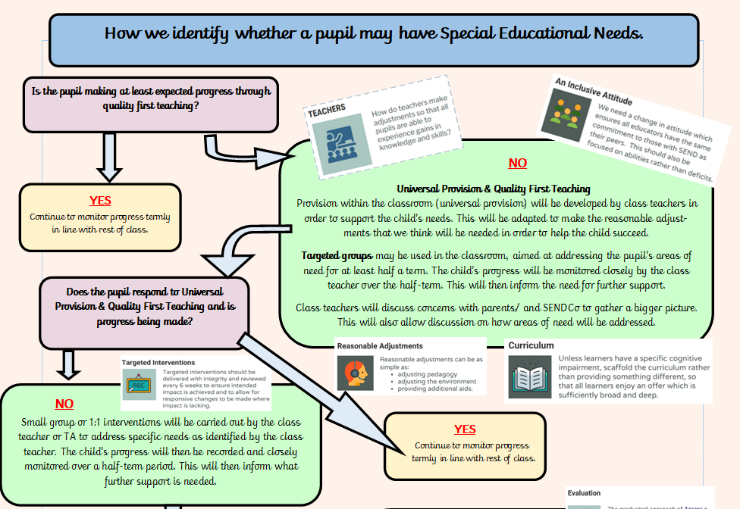
Appendix 1 – Graduated Response



