

Long Itchington Church of England Academy
Policy for Collective Worship

Our policy for collective worship is set in the context of and gives life to our Christian vision and values. It mirrors the Church of England Education Office guidance for collective worship Inclusive, invitational, inspiring 2021.
The law
By law collective worship:

- must be provided for every registered child every day
- must be in accordance with the tenets of its foundation and consistent with the denomination or religious tradition of the school in schools with a religious character

Our theologically rooted Christian vision
‘Working with all of our hearts in everything we do’
We love – we learn – we live

At Long Itchington Primary School we are ‘working with all our hearts in all that we do’ to enable everyone in our community to be nurtured and enabled to fully flourish in our Church school, whose Christian Foundation believes that:
God created human beings; he created them godlike, reflecting God's nature. Genesis 1:27
The bible describes God’s characteristics in many different ways. In our school we summarise these by saying that God is good (Psalm 119:68a) and God is love (1 John 4:8b).
We believe that God created everyone to be a unique, individual; a one off, capable of reflecting God’s goodness and love. Therefore, in our school ‘we are working with all of our hearts’ to create a culture in which everyone matters, everyone is loved, and everyone is valued, celebrated, represented - no exceptions.

Jesus said, ‘a new commandment I give to you, that you love one another: just as I have loved you, you also are to love one another (John 13:34)
Love is complex – it means different things at different times and sometime love is tough. In the bible it was an expression of God’s deep love that he sent his son Jesus to the world. Love is the reason for Jesus’ incarnation, life, teaching, death, and resurrection.
A Christian community is recognised by the way it loves. Therefore, ‘we are working with all of our hearts’ to create a culture where love is more than a word –where it is expressed and encountered by everyone, children and adults in our attitudes, behaviours, and intentions; from forgiving hearts where there is conflict and from generous, responsible hearts in the face of need.
‘We are working with all of our hearts’ to express love in community as justice; to make courageous responses to those in need, on the margins, without a voice, without aspiration, beginning with those within our doors and on our doorstep, who are not yet fully flourishing.
‘We are working with all of our hearts’ to speak the truth in love for the common good.

The Apostle Paul reminds us that a further expression of God’s love through us is our willingness to forgive, to reconcile, to allow fresh starts.
Bear with each other and forgive one another. If any of you has a grievance against someone - forgive as the Lord forgave you. (Colossians 3:13)
Christians believe that Jesus’ death and resurrection undid the separation of the Fall and brought people back into relationship with God. In our church school we recognise that in our school, community, and world there are fractures in relationships and the need for reconciliation is real.
‘We are working with all our hearts’ to ensure that restoring broken relationships, making amends with those who have been hurt or wronged, is at our school’s heart. We encourage honest dialogue, forgiveness, and sometimes self-sacrifice from those involved, in order to achieve peace and understanding and to enable everyone to flourish personally and spiritually. ‘We are working with all our hearts’ to ensure that our policies and processes reflect God’s concerns about relationships rather than rules so that everyone can be the best and fullest version of themselves.

Our core Christian values are captured in the image below and we learn about these values in our day to day activity and across our two year collective worship programme:
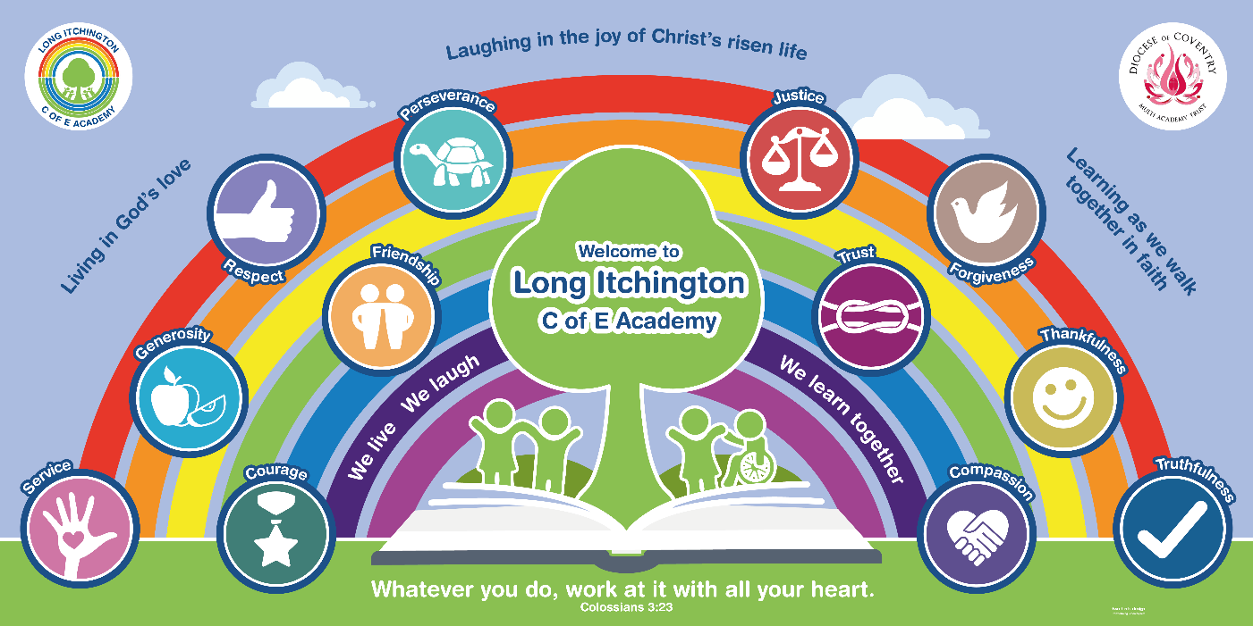

Collective worship and the Church of England
‘Church of England schools are committed to offering high quality collective worship. They are places that recognise and value collective worship as central to fostering a sense of community and to expressing the school’s Christian vision. In practice this means that structure, planning, evaluation, participation, collaboration, and inspection of worship are all taken seriously by the school and by diocese. We strive to ensure that collective worship remains the relevant and essential component of an education that enables all pupils to flourish and to ‘live life in all its fullness’ John 10:10. Collective worship is seen as more than a daily ‘awe and wonder’ moment. It is the unique heartbeat of the school and is offered as part of a wider opportunity for pupils and adults to encounter faith by engaging in conversations about God, both as individuals and together.
We aim for collective worship to be truly welcoming, inclusive and exemplifying the principles of Christian hospitality. This is an approach that seeks to meet the needs of all, wherever they may be on their journey of faith and belief.’
Inclusive, invitational, inspiring The Church of England education 2021
Inclusive, invitational and inspiring
We work to ensure that everyone in the school family has an enriching experience in collective worship.
Inclusive
In our collective worship we meet, explore, question, and respond to others and, for some, to God. We seek to ensure that all pupils, their families and other adults encounter worship that is inclusive of, and fully accessible to, all. We recognise that pupils and staff in our schools come from different faith backgrounds as well as of no faith background. We acknowledge that everyone is at different stages of their spiritual journey during their time in school. We give pupils the opportunity to think and ask questions. There is space to consent, and dissent: to participate and to stand back; and to consider. We take care to ensure that the language used by those facilitating worship avoids assuming faith in all those participating, listening and watching.
Collective worship will invite and welcome meaningful contributions from the whole school community, including pupils. We value pupils’ own experiences that they bring to worship. In our school inclusion is expressed through some pupil involvement in planning, leading and the evaluation of worship. We ensure that our collective school grows out of the local context and out of pupils’ experience, including their cultural backgrounds.
Invitational
We aim for our worship to be consistently invitational. There is no compulsion for pupils to do or say anything that makes them uncomfortable. We provide opportunities for pupils to engage whilst allowing the freedom of those of different faiths and those who profess no religious faith to be present and to engage with integrity. Pupils and adults are only invited to pray if they wish to do so and are invited to pray in their own way. Invitation to prayer is always to be accompanied by the option to reflect.
Music and liturgies used in worship reflect the best of traditional and modern Anglican worship. It connects with the theme wherever possible. They are used to enable pupils to explore the sacred, to educate and engage. We strive to choose music to reflect the diverse worship experience of the wider Christian community and the spiritual life of our school.
Inspiring
Pupils and adults can expect the worship they encounter in our school to be inspirational. Worship should enable pupils and adults to ask big questions about who we are and why we do what we do. It should motivate pupils and adults into action, into thinking differently, and into reflecting on their and the wider community’s behaviour and actions. As a result of inspirational collective worship, we aim for pupils and adults to be inspired to become courageous advocates for justice. Collective worship will encourage them to think searchingly about their faith, beliefs and/or philosophical convictions.
Right to withdraw
We acknowledge that there will always be those who are uncomfortable to enter through this open door of worship in our schools. The Church of England recognises the right of withdrawal from collective worship for those parents or pupils who wish to exercise this option. Parents wishing to exercise their right to withdraw should contact the headteacher to discuss this.
Aims and objectives
Collective worship in our Church of England school will:
- Explore our Christian vision and how that underpins shared values and virtues. In doing so, it will reflect on our core Christian values (above) and develop virtues such as resilience, determination and creativity that develop character and contribute to spiritual and academic flourishing.
- Help pupils and adults to appreciate the relevance of faith in today’s world by encountering the teachings of Jesus and the Bible and developing understanding of the Christian belief in the trinitarian nature of God.
- Offer the opportunity, without compulsion, to all pupils and adults to grow spiritually through experiences of prayer, stillness, worship, and reflection.
- Enable all pupils and adults to appreciate that Christians worship in different ways, for example using music, silence, story, prayer, reflection, as well as through the varied liturgical and other traditions of Anglican worship, festivals and, where appropriate ,the Eucharist.
- Enable pupils to develop skills through engaging in the planning, leading and evaluation of collective worship in ways that lead to improving practice.
Provision
The rhythm of daily worship in our school allows pupils and adults to step away from the rigour of the classroom, creating a space for an encounter with faith in God. It also provides the opportunity to reflect on larger questions of meaning and purpose. Our school’s collective worship practices provide a shared set of symbols, signs, words and actions and traditions which give our community a language upon which it can draw, in times of joy and grief. Collective worship is key to fostering a sense of fellowship and cohesion within our school community. Whether in times of crisis or celebration, this time set aside in the school day provides staff and pupils with the opportunity to gather and support one another as a community. Throughout the year, we meet to celebrate and mark seasons in the Church calendar, such as Lent and Advent. Other important events in the school year, such as the start and end of the academic year, are marked with special services, often in church.
Pupils and adults will encounter the practice of regular prayer and worship as a normal part of the life of the school. These activities help provide a rhythm and stillness as a pattern of community life. Worship in our school will follow a recognisable structure that will help focus worship on important themes. We use a welcome or prayer followed by a consideration of a Bible passage or story that we can then reflect on through discussion, prayer, silent reflection or music. It will be something that pupils and adults may want to share and discuss with others in school, in the community and at home. In this way worship overflows into our lives and choices.
The general pattern of our worship reflects that of an Anglican church service:
Gather | Gathering in a space with others | Stillness  Peace  Reflection  Together/community  Welcome  Releasing  Expecting Setting the atmosphere | Instrumental music Images A question to think about  Worship songs to join in  Lighting candles  Bringing things to the worship table including liturgical colours  Liturgical or other greeting
Engage | Engaging, getting involved | Hearing  Seeing  Learning  Wondering  Asking  Questioning  Experiences  Sharing  Thinking | Bible stories  Other stories Images Film/drama News  Vision and values  Talk partners Something to hold Church calendar  Community joys and sorrows
Respond | Responding to an invitation | Taking action  Acting for oneself  Acting for others  Living differently  Putting something right  Making a change  Making a commitment  Worshipping  Praying  Thinking about what I can learn about God,  myself, others, the world | Known prayers  Prepared prayers  Responsive prayers  In the moment prayers  Sensory prayers  Prayer walk  Teaspoon prayers (TSP)  Hand of prayer  Prayer tree/box/space/garden  Fill the blank prayers  Meditation
Send | Sending out/living life differently | Being inspired to:  Live well or differently  To pass the message on  To encourage and be encouraged  To love and be loved  To value and be valued  To make a difference  To make the world a little more like God intended | Known prayers  Sending liturgy  Take aways  Clergy blessing  Sing as you leave  Leave in silence  Leave to music

Our pattern for worship:
Worship patterns are timetabled termly, but always include family worship, whole school worship and class based worship. We also regularly have church visitors in school to lead worship, including the vicar and members of the local clergy. Teacher have regular opportunities to lead worship. Our medium term plans for worship are shared half termly with all staff.
Developing staff expertise and knowledge
Within the context of our resources, we work to build up the expertise of staff, pupils, clergy, and other adults in facilitating collective worship in our school. We strive to ensure that:
• Worship leaders, including clergy, have access to regular training, primarily through the diocesan education team.
• Pupil worship leaders are supported, encouraged, and resourced to contribute to meaningful acts of worship.
• Worship leaders, including clergy, have access to high quality and current resources.
• Those from outside agencies and church groups invited into the school to facilitate are properly briefed about the school, its pupil context and the school’s vision.
Monitoring and evaluation
- The governing body ensures monitoring of the impact of worship; this monitoring includes and meaningfully involves pupil voice.
- There is a named member of staff responsible for collective worship who ensures that appropriate policy and practice are in place and publicly available. This is Rebecca Richards.
References:
Church of England vision for education:
https://www.churchofengland.org/about/education-and-schools/vision-education
Church of England Education Office guidance on collective worship:
https://www.churchofengland.org/sites/default/files/2021-05/Collective%20Worship%20Guidance%2018052021.pdf
Date of policy: Spring 2024

Renewal date: Summer Term 2026 or when guidance changes

